CO2-AT1
NAME:S.JAYASHREE
REG NO:192471041
A data-import program receives a raw List from an old library and casts every element to Customer. Runtime ClassCastException occurs. Redesign the interface using generics to detect errors at compile time. [Generics]
Experiment: Java Generics – Compile-Time Type Safety
Aim
To design a Java program using Generics that replaces raw List usage with a type-safe List<Customer>, thereby detecting type mismatch errors at compile time instead of causing ClassCastException at runtime.

Pseudocode
START

Create Customer class.

Create a generic list of Customer.

Add customer "Alice".

Add customer "Bob".

Display customer details using a loop.

Print a message that Generics provide compile-time type safety.

STOP
Program
import java.util.ArrayList;
import java.util.List;

// Customer class
class Customer {
private String name;

Customer(String name) {
this.name = name;
}

public void display() {
System.out.println("Customer Name: " + name);
}
}

public class Main {
public static void main(String[] args) {

// Old approach (Raw List) - Not type safe
/*
List list = new ArrayList();
list.add(new Customer("Alice"));
list.add("Hello"); // Allowed in raw list

Customer c = (Customer) list.get(1);
// Runtime Error:
// java.lang.ClassCastException
*/

// Redesigned approach using Generics
List<Customer> customers = new ArrayList<>();

customers.add(new Customer("Alice"));
customers.add(new Customer("Bob"));

// customers.add("Hello");
// Compile-time Error:
// The method add(Customer) is not applicable for the arguments (String)

System.out.println("Customer Details:");
for (Customer c : customers) {
c.display();
}

System.out.println("\nGenerics prevent ClassCastException by detecting type errors at compile time.");
}
}
Output
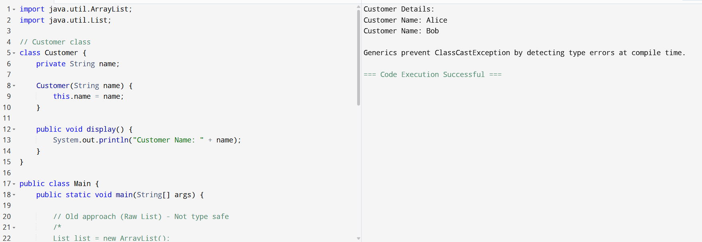
Result
Thus, the program was implemented using Java Generics (List<Customer>). Generics ensure compile-time type checking, preventing invalid object insertion and eliminating ClassCastException caused by raw collections.

